Website Content

Navigation

 Emily’s Personal Training Home, Classes, Reviews, Booking

Footer

Copyright © 2024 Patrik Horánszki

This personal project was made for a university assignment.



Pages

Home

Welcome to my page! I'm thrilled to have you here on your journey to a healthier, fitter you.

HEY!   
I’M EMILY

“If it doesn’t challange you, it won’t change you.”  
It’s my slogan and I will help you be the best you can be.  
I’m Emily Jones, I’ve been a Fitness Trainer since 2010, Fitness, Health, and Lifestyle Influencer.

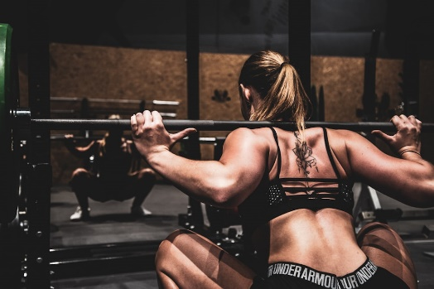

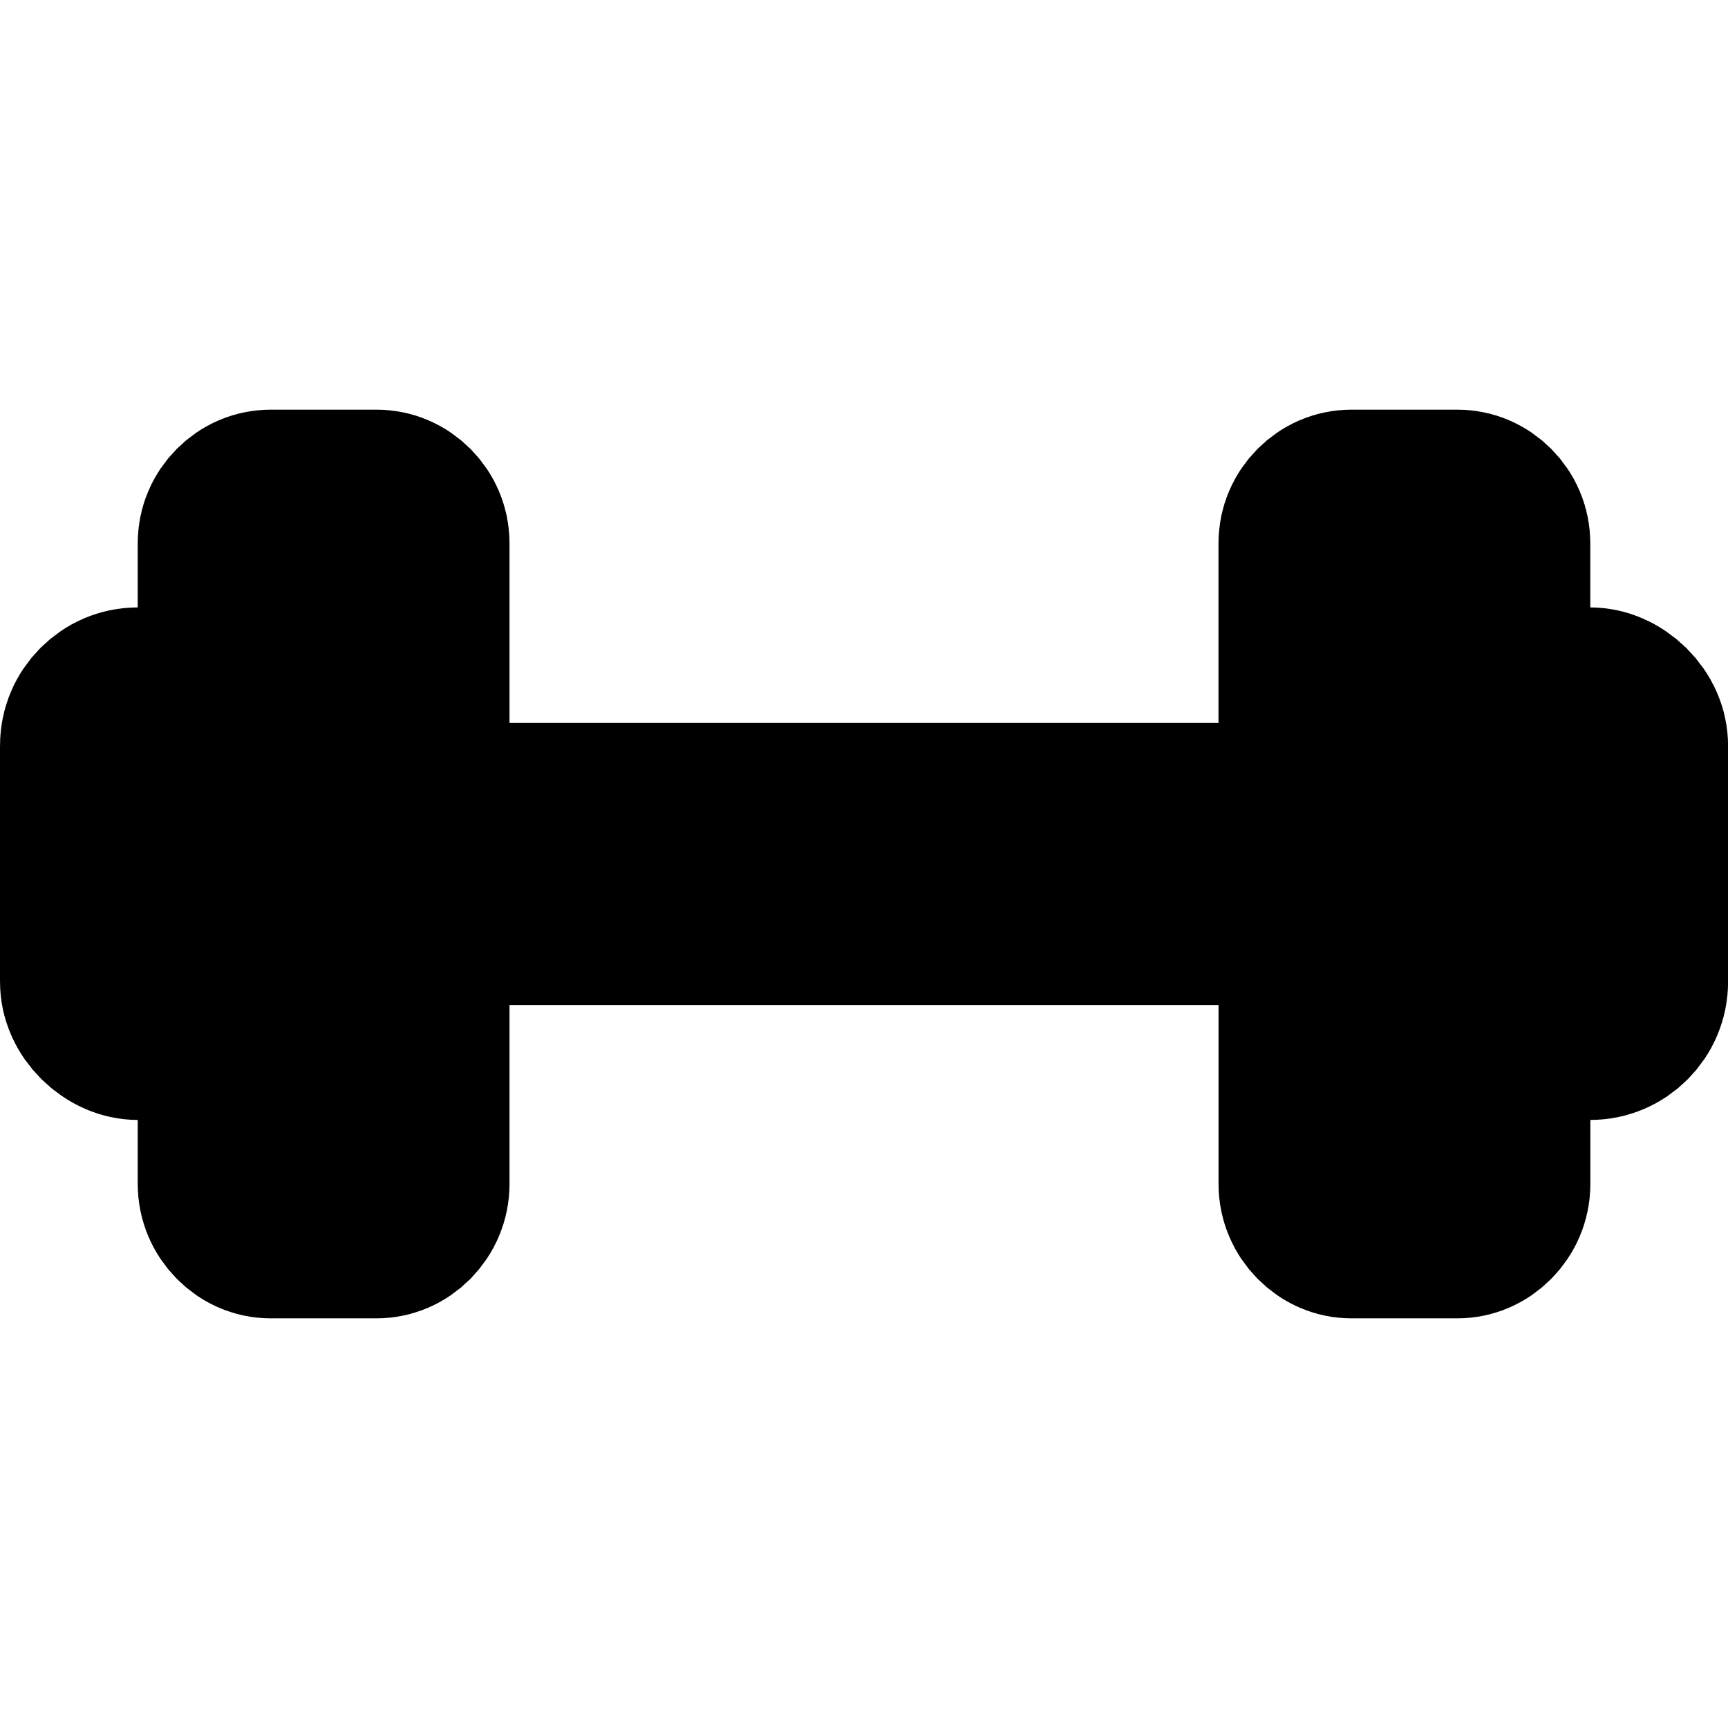 Private Session  
Indulge in focused, one-on-one guidance tailored to your unique fitness goals and abilities.

 Group Class

Join our energetic group sessions for a fun and motivating workout experience.

 Program & Diet

Transform your lifestyle with expertly crafted diet plans to fuel your journey.

Transform Your Body!

Witness the incredible transformation of your body as you sculpt, tone, and strengthen with targeted workouts and personalized nutrition plans, unlocking the best version of yourself.

Classes

Group Classes

|  |  |  |  |
| --- | --- | --- | --- |
| Class Title | Days | Time | Duration |
| HIIT | Fridays | 8:30 | 60 minutes |
| Yoga Flow | Saturdays | 15:30 | 40 minutes |
| Lower Body | Sundays | 16:00 | 60 minutes |

 HIIT Training

Burn calories fast with my intense High-Intensity Interval Training class, combining bursts of high-energy exercises for a full-body workout in less time.

 Yoga Flow

Unwind and strengthen with my Yoga Flow class, blending breath, movement, and relaxation for improved flexibility and inner peace.

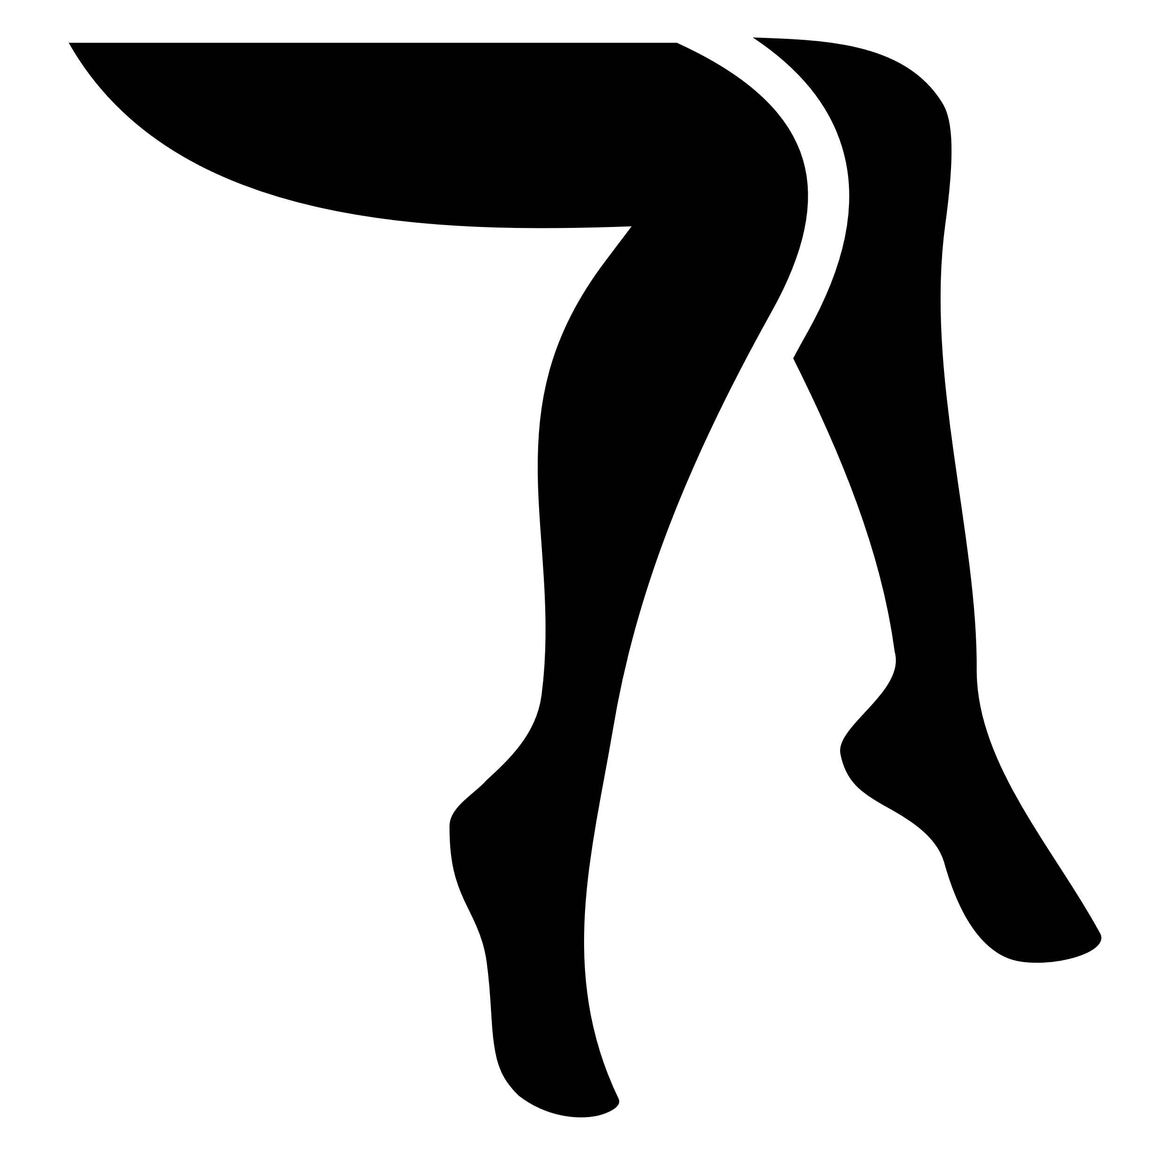 Lower Body

Sculpt and tone your legs, glutes, and core in our Lower Body Burn class, featuring targeted exercises to strengthen and define your lower body for a firmer, more powerful silhouette.

Reviews

Customer Reviews

 Jessica Sky

I absolutely love the Yoga Flow class! It's the perfect way to unwind after a busy day, and I always leave feeling refreshed and rejuvenated.

 Isabella Martinez

Lower Body class has been amazing for targeting my legs and glutes! The exercises are challenging yet effective, and I can already feel myself getting stronger and more toned.

 Chloe Johnson

HIIT sessions are amazing! The intensity keeps me motivated, and the bursts of activity make the time fly by. I've seen incredible improvements in my endurance and overall strength since starting. 

Tough Beginning?

Feeling intimidated at the gym for the first time? Watch this empowering video guide designed to ease your nerves and boost your confidence as you step into the gym for the first time, ensuring a positive and fulfilling fitness journey ahead.

[https://www.youtube.com/watch?v=XIYuxAeKSM0] View video transcript

Booking

Class Booking

Ready to take the next step towards achieving your fitness goals? Booking your classes couldn't be easier! Simply fill out the form below to secure your spot in my invigorating workouts. Whether you're a seasoned gym-goer or just starting your fitness journey, our classes offer something for everyone. Don't wait any longer to prioritize your health and well-being - reserve your spot now and join us for an energizing session!

**[form]**

Name

(Your name)

Email

([you@example.com](mailto:you@example.com))

Fitness Goals (Optional)

(Tell me a little about your fitness goals)

**[checkbox]** I want to receive reminders about upcoming booked classes

Classes

**[radiobutton]** HIIT

**[radiobutton]** Yoga Flow

**[radiobutton]** Lower Body

**[button]** Reset Form

**[button]** Apply

Thank you for booking your class with us! We're thrilled to have you join our fitness community. Get ready to sweat, smile, and achieve your goals together. See you soon in class!

Video Script

**[Noel Deyzel, a muscular tall man is talking in front of the camera]**

I just want to say that I'm really proud of you for clicking on this video. By doing that it means that you're willing [and wanting to put the effort into](javascript:;) [yourself as well as your health and your](javascript:;)  
future. I really hope that this video helps you. Starting in the gym can be overwhelming and straight up confusing here's your guide to starting in the gym and doing your best to stay consistent. Let's start off with something that's personal to you: your goals. In the gym we can go down so many different parts, be it CrossFit **[video with 10 crossfit athletes during competition]** powerlifting **[video of a big muscular man deadlifting 501 pounds]** or even my forte: bodybuilding **[video of Chris Bumstead posing during competition]** Whatever your goals you should develop a general idea of what it is you want to achieve in the gym this will ensure that you're happy in the gym doing what you love. It's something that you really should know is that your goals may change over time. The gym you choose should be environment that you're comfortable with. Unfortunately there should be a lot of options available from commercial gyms **[video of a commercial gym with nautilus machines]** to very secure private gyms **[video of a luxury private gym]** to even most hardcore gyms. **[video of a gym cluttered with machines]** You need to visit a gym that you feel comfortable in and just check it out. Most commercial gyms offer a tour or three-day pass to check them out. Now that you have these two things under the belt, let's get you prepared for the gym. If you have no history in the gym what I would suggest is doing some research online. Watch some YouTube video of others working out. It may seem a little bit weird but it's a great way for you to develop an understanding of the different machines and it's also a great way to see the different movements. This brings me on to the next step of preparation. Developing your workout routine or split. Now again, this is going to entirely depend on your goals, and my forte is bodybuilding. So we're going to use bodybuilding as a reference. For most beginners I suggest starting on a lower and upper split. Now you're probably wondering what that means. It essentially means you're going to be dividing the days you're working out by either upper or lower body. And here's some examples of it**. [video of a muscular man in a leg press machine]** Now this usually works very well for beginners. But if it's not enough, the next step I suggest is PPL. Which means Push Pull Legs. All synergistic muscle groups are work together. Meaning on push days when you try your chest, your shoulders are activated with your triceps. **[video of Noel training his chest and shoulders]** And you work your shoulders, your chest and triceps are activated as well. This is a great way to develop good mind muscle connection, which helps with strength, muscle growth, and a good understanding of your body. Here are some examples of PPL. Now that you've got your plan let's talk about your first day. Depending on how anxious you feel about working out around others I suggest going a time and you feel comfortable. Gyms are generally less busy around 10 to 2 p.m, and from 7 pm to closing time. So now you're at the gym doing your first exercises. **[video of a man adjusting a machine in a commercial gym]** Don't worry about what weight you use. Even if you put it on the lightest weight to simply just feel how the machines feel. And you can do this forever how long you need until you feel comfortable. Now when you're ready increase the weight slightly, then go for around 10 to 12 Reps for four sets each. Do this for each and every exercise and then you can move on reps meaning the amount of times you do a single movement of an exercise. Sets being the number of times that you do the group of repetitions. Now there's a few things I want you to remember on day one. The gym is a place we should all feel comfortable. All the people in the gym have been in the same position that you are. Just starting out and they understand what it feels to be in that position. If you feel more comfortable being in the gym with someone else it's a great way to start out too. Speak to a friend, colleague or family member and see if they're willing to start on this journey with you. So some times gone by now and you're moving forward in your journey. Now you're probably asking how do I stay motivated? How do I keep going to the gym even if I don't feel like it? One thing you have to remember is that the gym is a lifestyle change. It's a slow and beautiful process that you should enjoy. Remind yourself of why you're doing this. It's a time for you to focus on yourself. But nonetheless establishing the Gym to your routine is a great way to stay consistent. Go every day at the same time and even on the days you don't feel like it give yourself the opportunity and still go. Even if you don't give a hundred percent something is still better than nothing. That consistency is going to make it easier over time and ingrain it into your lifestyle. The gym will truly change your life, and if you feel this video helped you, please leave a like or a comment or whatever you feel so that we can get this video to see as many people as possible. Thank you so much for watching. See you next time. **[Noel’s hand approaches the camera while the video ends]**